2017 juvenile salmon migration report: northern Strait of Georgia to Johnstone Strait

— Hakai Institute Juvenile Salmon Program —

Brett Johnson, Carly Janusson, Julian Gan, and Brian Hunt

Latest Update: 2017-06-07

## Aim

To provide in-season summaries of juvenile Fraser salmon catch statistics, health indices, and oceanographic conditions in the northern Strait of Georgia to Johnstone Strait region.

## Background

The Hakai Institute Juvenile Salmon Program was launched in the spring of 2015 in a collaborative partnership with UBC, SFU, Salmon Coast, Pacific Salmon Foundation, and DFO. The program operates in the Discovery Islands and Johnstone Strait (Figure 1) and thus provides information on the health of juvenile Fraser River salmon after passage through the:

1. Strait of Georgia – stratified high plankton biomass zone; and
2. Discovery Islands & Johnstone Strait – highly-mixed low-plankton biomass zone, and area of high wild-farmed fish interactions.

## Program Objectives

1. Determine migration timing and pathways;
2. Migration habitat mapping - oceanographic conditions along the migration route;
3. Understand the dynamics of the plankton food-webs that underpin juvenile salmon growth and health;
4. Understand parasite and pathogen infection dynamics and their impact on juvenile salmon growth and health.

## Parameters Reported:

### Catch Per Unit Effort

### Cumulative Abundance of Sockeye by Region

### Cumulative Abundance of all Species

### Sea Lice Abundance

### Sea Lice Prevalence

### Fish Length

### Fish Weight

### Zooplankton Biomass

### Chlorophyll a

### Sea-surface Temperature

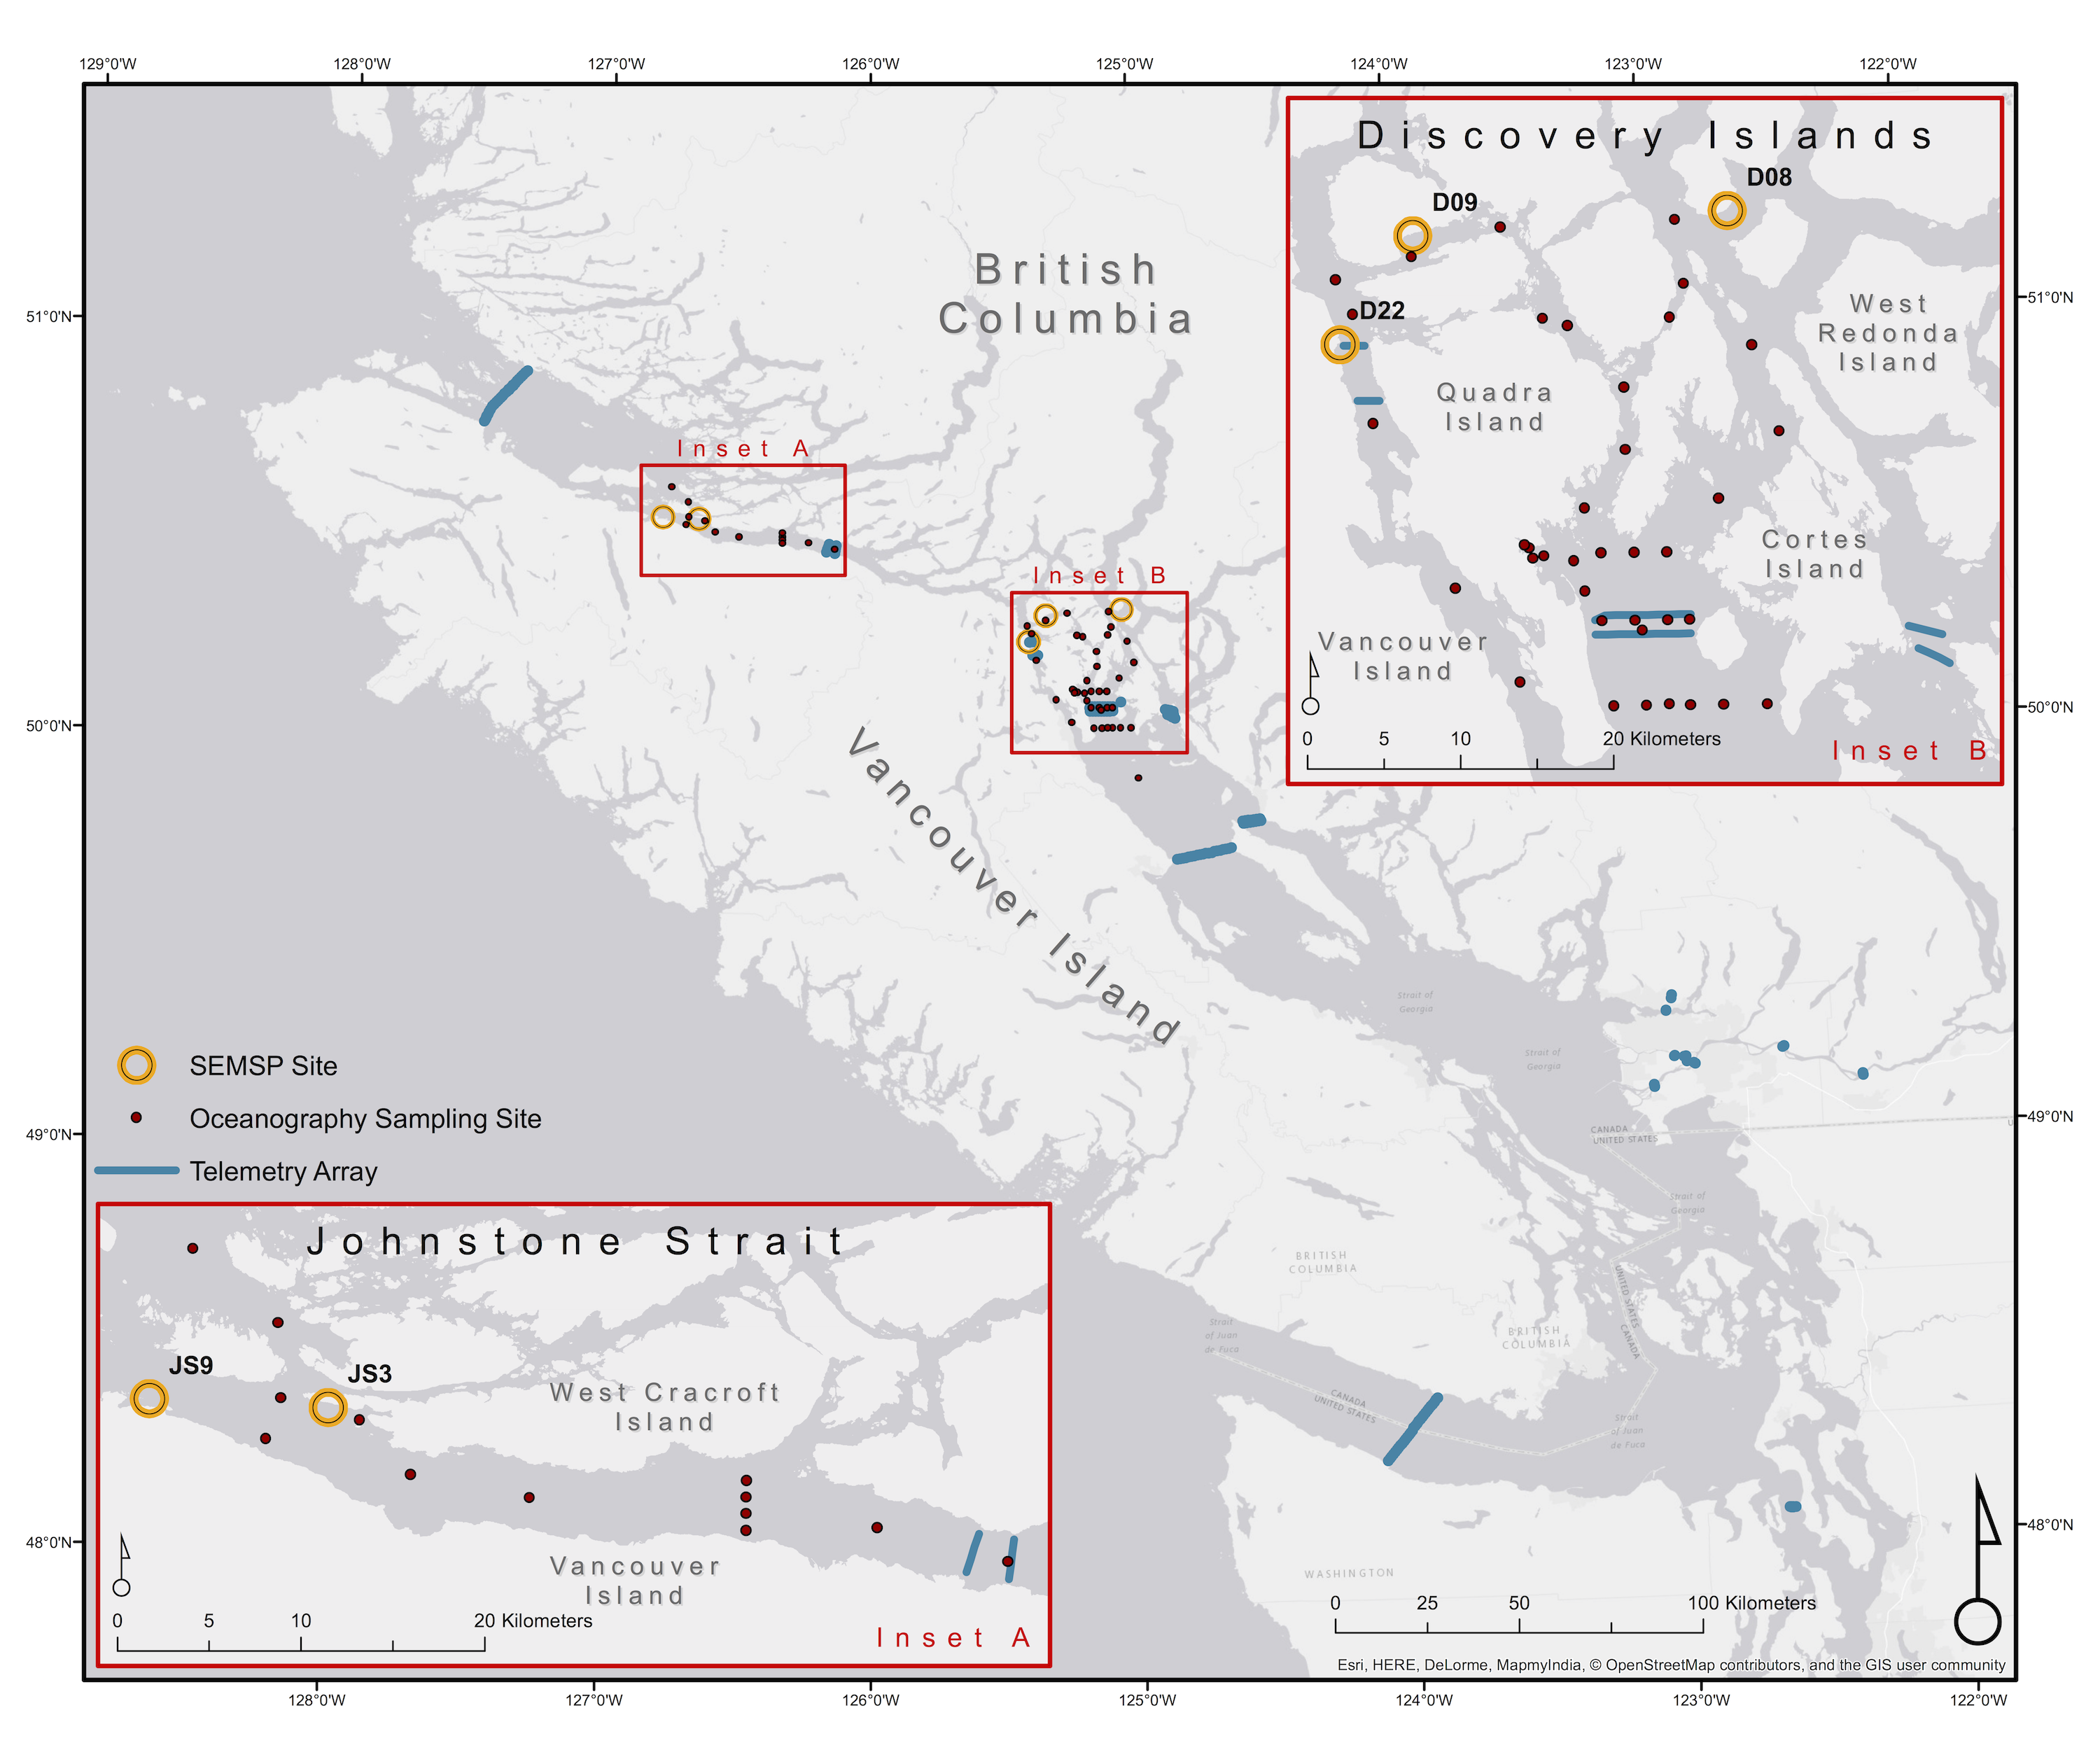

Salmon sampling locations in 2017 (yellow circles).

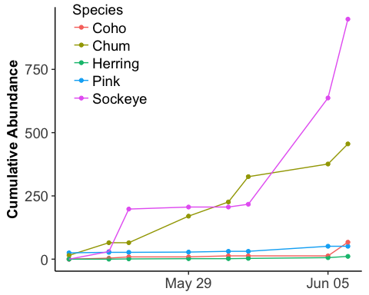

The cumulative abundance of fish captured in the Discovery Islands and Johnstone Strait in 2017.

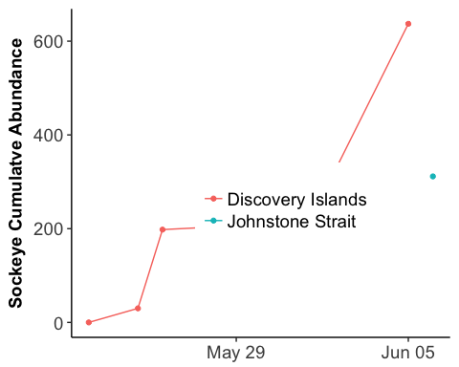

The cumulative abundance of sockeye captured in the Discovery Islands and Johnstone Strait in 2017.

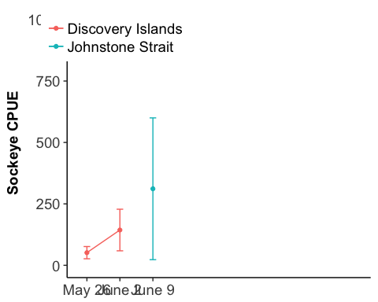

The catch per unit effort (CPUE) of juvenile sockeye salmon in 2017 averaged over one week periods for each region. Error bars represent standard error of the mean.

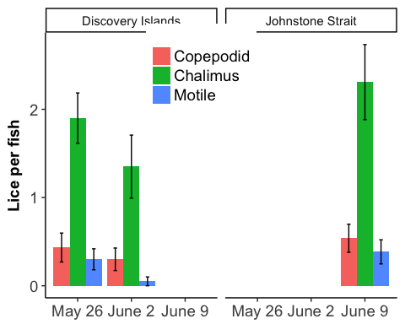

The average abundance of three developmental stages of *Leptheoptheirus salmonis* or *Caligus clemensi* sea lice per juvenile sockeye salmon.

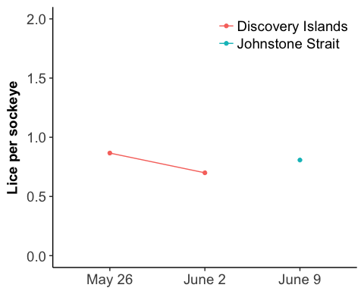

The prevalence rate of all developmental stages of *Leptheoptheirus salmonis* or *Caligus clemensi* sea lice present on juvenile sockeye salmon in the Discovery Islands and Johnstone Strait in 2017.

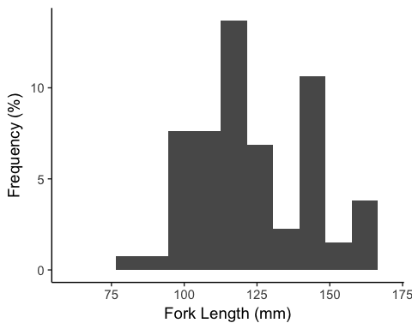

Length frequency histogram of juvenile sockeye in the Discovery Islands and Johnstone Strait in 2017.

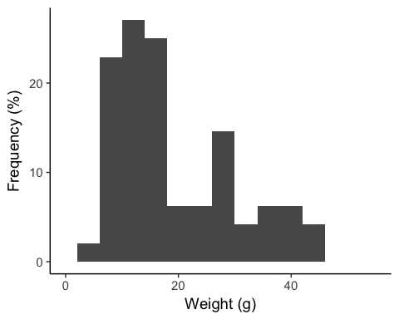

Weight frequency histogram of juvenile sockeye salmon in the Discovery Islands and Johnstone Strait in 2017.

## Zooplankton Biomass

## Chlorophyll a

## Sea-surface Temperature

# Highlights

* Bullet highlights from the data